DC power supply

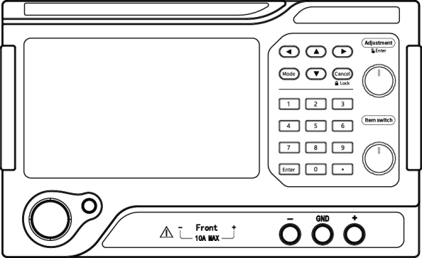

High power PL series power supply
product instruction manual

Catalogue
Safety Summary 1
Charpter 1 summary 3
Charpter 2 Operation panel introduction 4
2.1 front panel 4
2.2.1 Power switch 4
2.2.2 ON/OFF key 4
2.2.3 Normal mode interface 4
2.2.4 Menu interface 6
2.2.5 Charging display interface 9
2.2.6 Charging parameters interface 10
2.2.7 Fuse mode interface 11
2.2.8 key 14
2.2.9 Adjustment knob 14
2.2.10 Focus shift knob 14
2.2.11 Output channel 14
2.3 Back panel 15
Charpter 3 operation declaration 17
3.1 parameter setting 17
3.2Move the cursor focus 17
3.3Function mode switching 17
3.4 power output 18
3.5 Constant voltage source and constant current source 18
3.5.1 constant pressure source 18
3.5.2 constant-current source 20
3.6 Battery charging 21
3.7 Fuse test 22
3.7.1 Fuse time mode 22
3.7.2 Fuse current mode 23
Charpter 4 Performance index 25
4.1 Display resolution 25
4.2 Time display range 25
4.3 Output parameters 26
4.4 Voltage and current value preset accuracy 26
4.5 operational environment 26
4.6 Storage environment 26
4.7 power input 27
4.8 appendix 27
4.9 Bare machine size 27
4.10 Packing size 27
4.11 communicational parameter 28
4.12 Weight 28
Charpter 5 Product toxic and harmful substances declaration 29
Charpter 6 conformally connected space 30

No further notice will be given if there is any change in the performance indicators.

Safety Summary
This chapter contains important safety instructions that must be followed for operating the power supply and storage environment. To ensure your personal safety, please read the instructions carefully before operation to ensure that the power supply is in the best working environment.

Safety Guide
General Introduction    Attention | - Do not place heavy objects on the housing.
 | - Avoid serious impact or improper handling resulting in machine damage.
 | - Take measures to prevent electrostatic discharge when connecting instruments.
 | - Do not block or isolate fan vents.
 | - Do not open the machine unless you are a professional.
Power supply   Warning | - AC input voltage: 220V±10%,50Hz (or 110V±10%,60Hz).
 | - The grounding wire of the power line should be connected to the grounding end to avoid electric shock.
 | - Make sure you use the correct fuse model before turning on the machine.

fuse  Warning | - To prevent fire, replace the fuse with a model and rated value.
 | - Cut off the power supply before replacing the fuse to eliminate the cause of the fuse damage.
Cleaning machine | - Cut off the power before cleaning.
Cleaning machine | - Wet a soft cloth with mild detergent and water. Do not spray the cleaner directly.
Cleaning machine | - Do not use chemical or cleaning products containing abrasives such as benzene, toluene, xylene and acetone.
operational environment | - Where to use: indoors, away from direct sunlight, dust and strong magnetic fields.
operational environment | - Relative humidity: <80%
operational environment | - Altitude: <2000m
operational environment | - temperature ：5℃~40℃
Storage environment | - Location: Indoor
Storage environment | - Relative humidity: <70%
Storage environment | - temperature ：0℃~70℃

- summary
This series of products has high power output performance, and added battery charging mode and fuse mode. It uses 5-inch LCD screen to display, which makes the display brighter and intuitive. It meets the needs of more different customers.

- 5 inch LCD screen partition display, using advanced embedded operating system.
- Battery algorithm curve charging function.
- Powerful fuse blown test function.
- Output positive timing and countdown test function.
- Supports MODBUS RTU protocol, standard RS485 interface, supports optional USB, RS232 communication interface.

- Operation panel introduction
  - front panel
  - 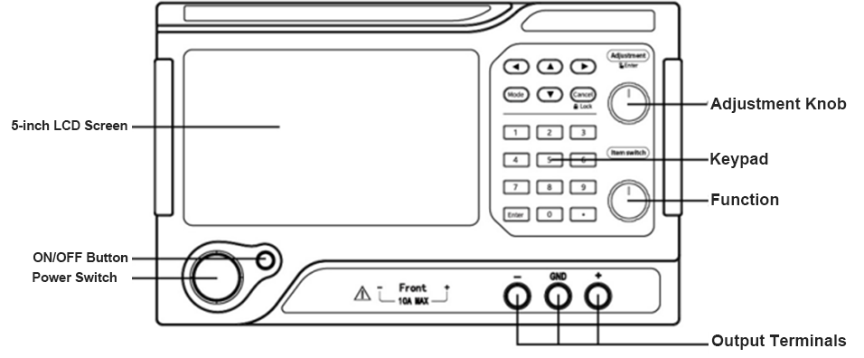
Focus Shift knob

    - Power switch
Used to connect or disconnect the power supply. Press to connect the power supply.

    - ON/OFF key
This button can switch the output state of the power supply, red is to turn off the output, green is to turn on the output.

    - Normal mode interface
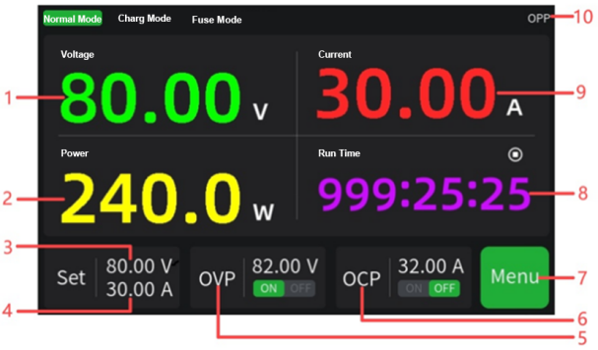
- Output voltage: Power output voltage display window, unit: volts (V).
- Output power: the display window of the power output of the power supply. Power = voltage * current, unit: watt (W).
- Preset voltage: Voltage preset window, unit: volts (V).
- Preset current: Current preset window, unit: ampere (A).
- Overvoltage Protection (OVP): The overvoltage protection setting window. The value represents the overvoltage protection threshold in volts (V). If the output voltage exceeds this protection threshold, the power supply will automatically shut down and OVP will be displayed in the upper right corner of the interface. The string represents the switch status of overvoltage protection, where "OFF" means off protection and "ON" means on protection.
- Overcurrent Protection OCP: Overcurrent protection setting window. The value represents the overcurrent protection threshold, unit: ampere (A). If the output current exceeds this protection threshold, the power supply will be automatically shut down and OCP will be displayed in the upper right corner of the interface. String represents the switch status of overcurrent protection. "OFF" means to turn off the protection, and "ON" means to turn on the protection.
- Menu menu: Select to enter the Menu interface, set address, startup output mode, compensation mode, timing mode, USB mode, baud rate and other parameters.
- Running time: The output time of the power supply, unit: seconds (s), used with the timing mode in the Menu.
- Output current: Power supply output current display window, unit: ampere (A).
- Power output status: Display the current output status of the power supply. CV is constant voltage mode; CC is constant current mode; OVP is overvoltage protection mode; OCP is overcurrent protection mode; OPP is overpower mode.
    - Menu interface
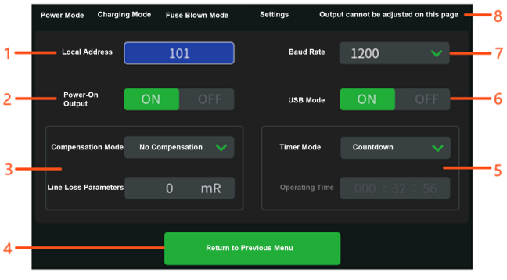
- Local address: The communication address of the power supply, range: 0-250.
- Power on output status: Set the output status after power on. "OFF" means that the output is kept off after power on (i.e., power on), and the ON/OFF button is bright red; "ON" means that the output is directly opened after power on (i.e., power on), and the ON/OFF button is bright green.
- Compensation mode: this mode is divided into no compensation, linear compensation and hardware compensation.
- No compensation mode means that the compensation function is turned off.
- Linear compensation mode: Calculate the line loss resistance value of the output line inside the power supply, increase the corresponding output voltage to compensate for the loss voltage, and make the output more accurate. This function requires setting the line loss compensation resistance parameter.
- The hardware compensation mode compensates the voltage drop at both ends of the load through the sense output. The connection mode is as follows:
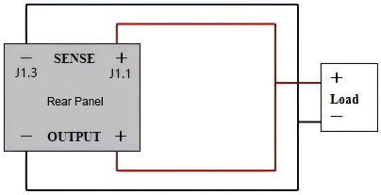
- Return to the superior page: Return to the normal mode interface.
- Timing mode: The output timing mode is divided into three modes: countdown, pause of positive timing, and reset of positive timing. It is used in conjunction with the running time of the normal mode interface.
- Countdown mode: When the countdown is over, the output is turned off. You need to set the running time (that is, the countdown time of the output).
- Normal timing pause mode: the power output is turned off, and the timing is paused; when the output is opened again, the running time will not be reset, and the timing will continue.
- Normal reset mode: resets the timer for each output.
- USB mode: used to upload the startup interface. This mode requires the outer shell to be removed. Please contact a professional for operation.
- Port rate: Power communication port rate, optional 1200,2400,4800,9600,19200,38400,57600,115200.
- This page cannot adjust the output status: indicates that the interface cannot be output, and you need to return to the normal mode interface and then press the ON/OFF button to be effective.

    - Charging display interface
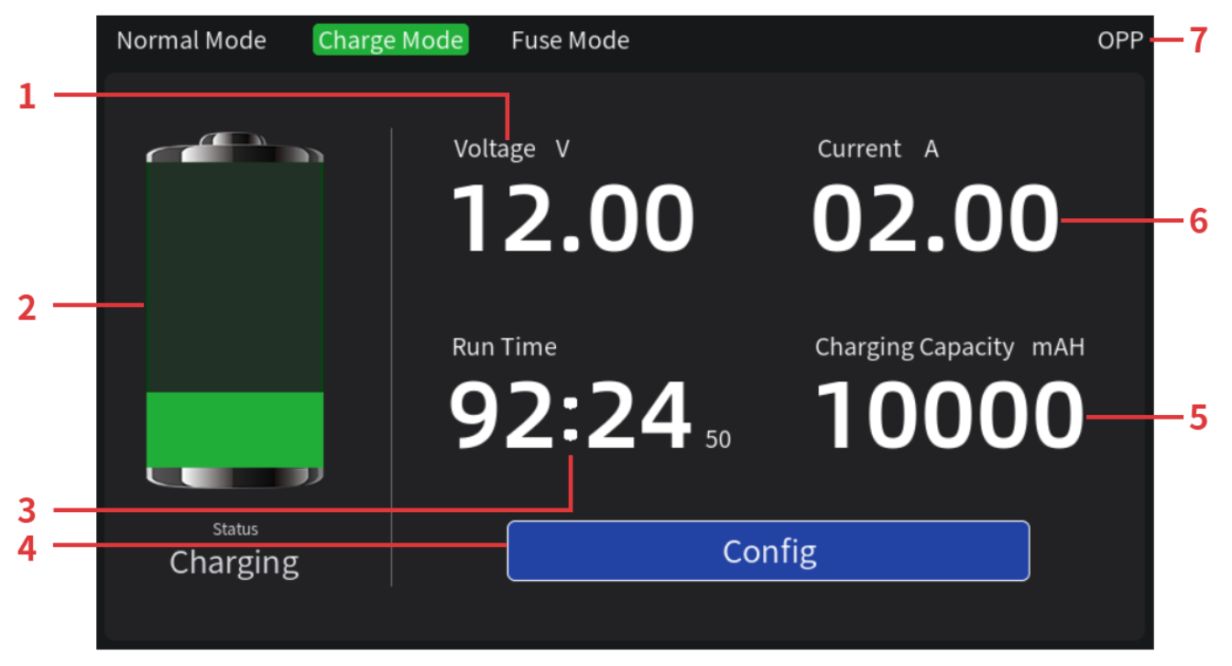
Battery charging dedicated interface
- Real-time voltage: the real-time voltage of charging, unit: volts (V).
- Charging status: it is divided into five states: idle, pre-charging, charging, charging completed and timeout.
- Running time: the cumulative battery charging time.
- Modify the charging parameter menu: you can set the charging parameters in the interface.
- Charging capacity: the battery has been charged capacity, unit: mAh.
- Real-time current: the real-time current of battery charging, unit: Abe (A).
- Power output status: indicates the power charging output status. CV is constant voltage mode; CC is constant current mode; OVP is overvoltage protection status; OCP is overcurrent protection status; OPP is overpower status.

    - Charging parameters interface
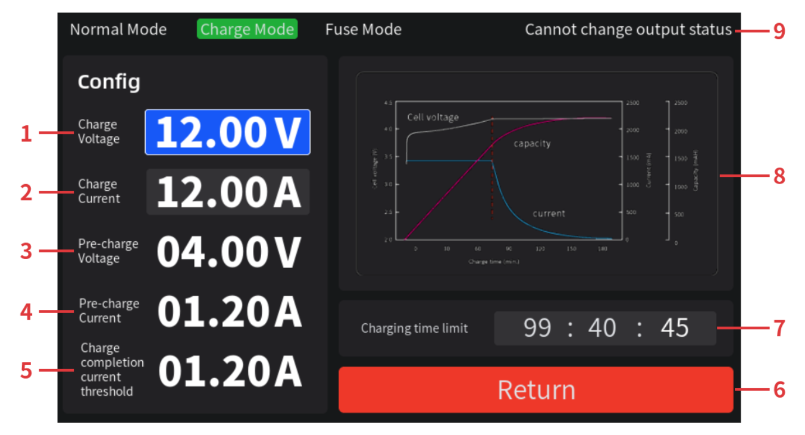
- Charging voltage: constant voltage charging voltage, unit: volts (V).
- Charging current: constant current charging current, unit: ampere (A).
- Precharge voltage: trickle charge voltage, the fully discharged battery unit is first to precharge (restorative charge), unit: volts (V).
- Precharge current: trickle charge current, a precharge (restorative charge) for a fully discharged battery unit, in units of amperes (A).
- Charging current threshold: The charging will be terminated when the power output current is detected to be less than or equal to this threshold. Unit: Ampere (A), the output will be turned off.
- Return to the superior page menu: return to the charging mode display interface.
- Charging time limit: Limit the battery charging time. When the accumulated charging time reaches the set value, the power supply will turn off the charging mode (turn off the output).
- Charging curve: the process curve of charging a battery (non-dynamic).
- This page cannot adjust the output status: it means that charging cannot be output when entering this interface, and you need to return to the charging display interface and start charging by pressing ON/OFF button.

    - Fuse mode interface
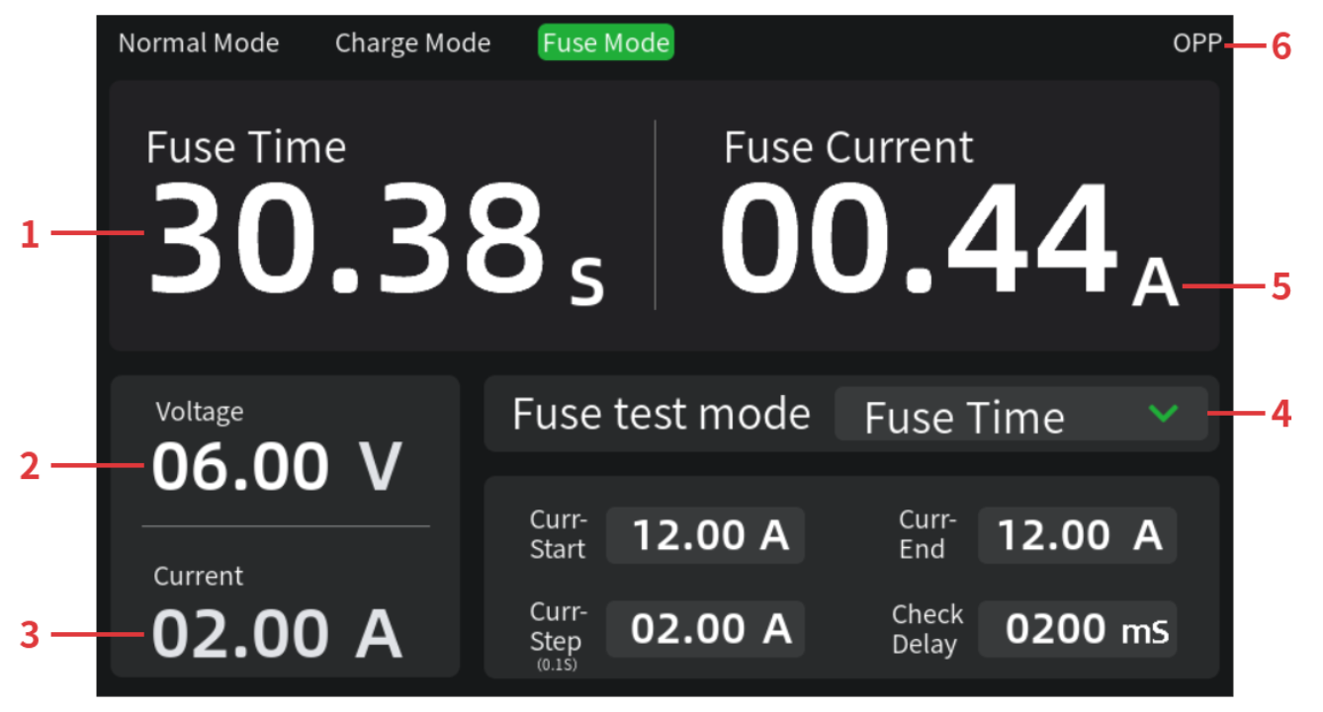
- Fuse time: the cumulative time of the fuse blown, and the time recorded by the fuse blown only under the timer, unit: seconds (s).
- Real-time voltage: the real-time voltage between the two ends of the fuse when the power supply is connected, unit: volts (V).
- Real-time current: the real-time current flowing through the fuse when the power supply is connected. Unit: Abe (A).
- Fuses test mode: divided into only fuse time and fuse current mode.
- Fuses current: the real-time current flowing through the fuse, and the current recorded when the fuse melts in fuse current mode, unit: Abe (A).
- Power output status: indicates the current output status of the power supply. CV is constant voltage mode; CC is constant current mode; OVP is overvoltage protection mode; OCP is overcurrent protection mode; OPP is overpower mode.

      - Fuse time interface
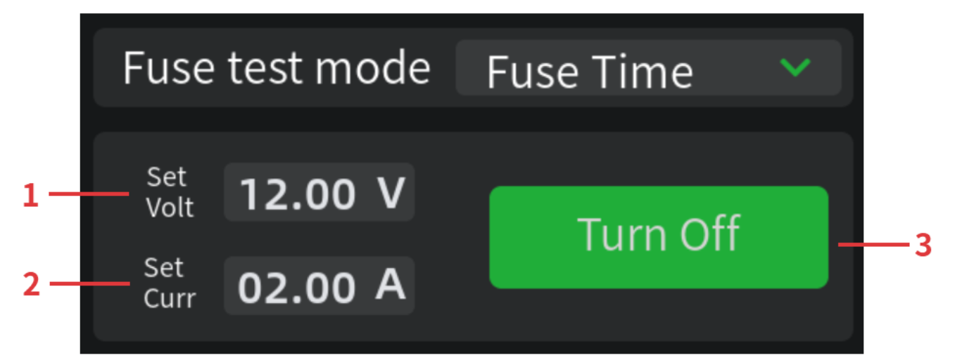
Only the fuse time mode is used to test the fuse time under a certain current.
- Set voltage: preset voltage for fuse test, unit: volts (V).
- Set current: preset current for fuse test, unit: ampere (A).
- Output setting after fuse break: It is divided into closing the output after break and maintaining the output after break.

      - Fuse current interface
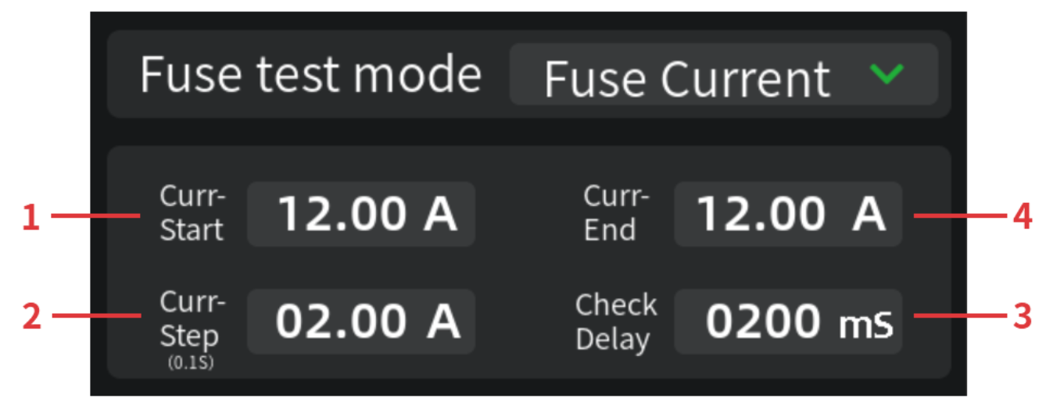
The fuse breaking current mode is used to test the critical current value of the fuse breaking in an instant.
- Current starting point: The starting point of the step change in current, unit: ampere (A).
- Current step (0.1 s): The current that steps every 0.1s, unit: ampere (A).
- Delay detection: After the corresponding time delay, the fuse current test is opened. Unit: milliseconds (ms).
- Current endpoint: the target value of the output current step change before the fuse melts, unit: ampere (A).

    - key
▲▼◀▶ | The position of the mobile focus
Mode | Switch between three modes (normal mode, charging mode, fuse mode)
Cancel | Short press to cancel the editing of the wrong parameters;  Long press the lock/unlock button (except the ON/OFF button)
0-9 | numbering key
. | radix point
Enter | Confirmation key

    - Adjustment knob
Use 1: All parameters are set according to 3.1 in Chapter 3.
Use 2: Switch status of all functions switching.
Use 3: Enter the drop-down menu and confirm the selection.

    - Focus shift knob
Focus shift.

    - Output channel
From left to right are the output negative electrode, grounding terminal, and output positive electrode. The output current range is 0~10A. If the output current is greater than 10A, select the output at the back end. 2400W (inclusive) The above models do not have this port.

  - Back panel
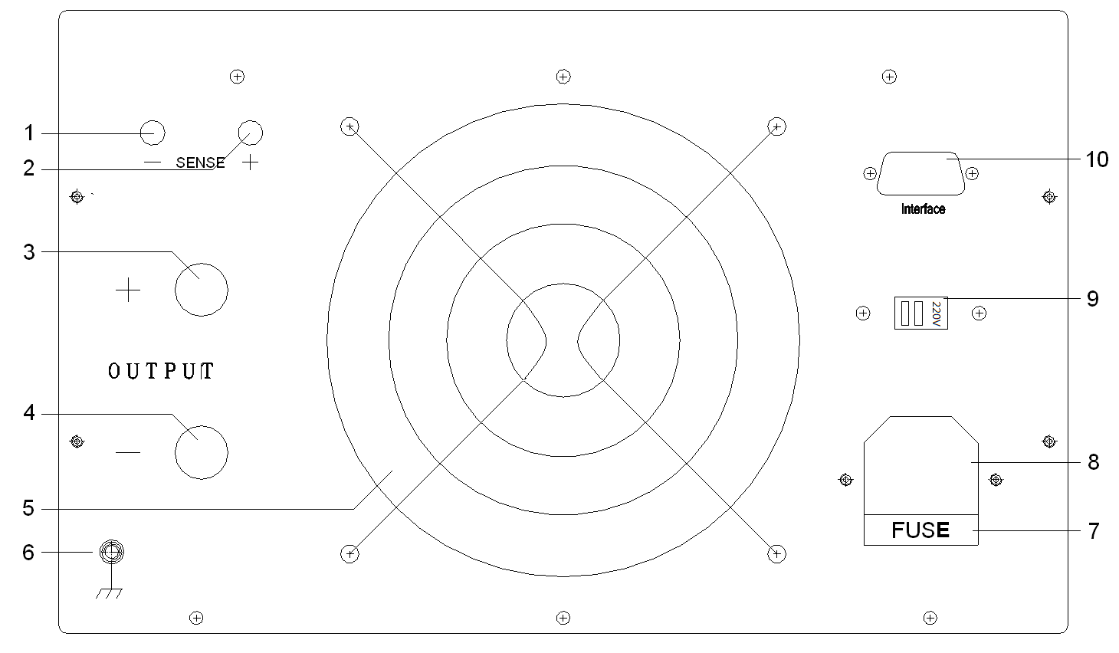
- SENSE negative electrode: the far end sampling point of the power output voltage negative electrode.
- SENSE positive: far end sampling point of the positive power output voltage.
- Output positive pole: The power supply outputs a positive (+) pole.
- Output negative pole: The power supply outputs a negative (-) pole.
- Fan air outlet: used for power supply air cooling. The fan can be started according to the internal operating temperature of the power supply, effectively reducing standby power consumption and prolonging the life of the fan.
- The grounding terminal:The ground wire terminal are connected to the power supply housing.
- Fuse holder: contains a power fuse, which can be replaced by screwing it open with a straight screw. Note: Models above 2400W (inclusive) do not have fuse holder, but built-in circuit breaker.
- Power input socket: AC input port. For models with 2400W (inclusive) or more, a cable is drawn out here to connect to the AC input.
- Communication interface: RS485 communication serial port is standard, RS232/USB interface is optional. MODBUS communication protocol is supported to realize the reading or control of power output value.

- operation declaration

3.1 parameter setting
Power parameter setting can be done in two ways.
- Number key +Enter: Edit input parameters through the number key and press Enter to confirm.
- Adjustment knob: Short press the encoder from right to left to move the number of bits of parameters, and rotate the adjustment parameter value from left to right.

3.2Move the cursor focus
There are two ways to move the cursor focus.
- Direction key: Click the ▲▼◀▶ key to move the focus to the window to be edited.
- Focus shift knob: rotate clockwise or counterclockwise to move the focus position.

3.3Function mode switching
- Switching between three functional modes: normal mode, charging mode and fuse mode can be switched from left to right by the Mode button.
- Pull-down menu mode switch:

Mode changes with a green dropdown can be changed in either of the following ways.
- Short press the adjustment knob to enter the drop-down menu, rotate the knob to select the items, and short press the knob to confirm the selection.
- Press Enter to enter the drop-down menu, press arrow keys to select the items, and press Enter to confirm the selection.

3.4 power output
The normal mode, charging mode and fuse mode are independent, and the output of each functional mode must correspond to its display interface.
If there is a prompt in the upper right corner of the screen indicating that output is not possible, you need to return to the superior interface to enable output.

3.5 Constant voltage source and constant current source
The power supply provides two power output modes: constant voltage source (CV) and constant current source (CC).

3.5.1 constant pressure source
For example, if the voltage is set to 30, the current is set to the maximum rated value, and the load connected is 10Ω/300W.30V/10Ω=3A <maximum rated value 20A, so the power supply is output as a constant voltage source 30V.
operating steps:
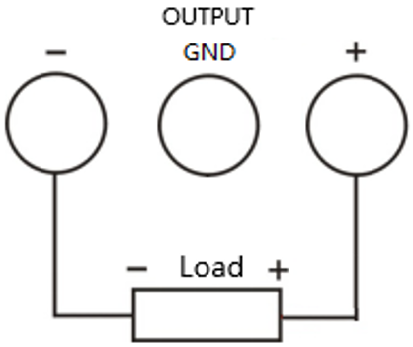
- Turn on the power: press the power switch to start the power and enter the working state.
- Voltage setting: Set the voltage to 30V through a digital key or adjustment knob, referring to 3.1 parameter setting in Chapter 3.
- Current setting: Move the focus to the current setting window by the focus shift knob or direction key, and set the current to the maximum rated value of 20A by the digital key or adjustment knob.
- Connect the output lead: connect the power output terminal to the load in the way shown in the figure above.
- Open the output: press the "ON/OFF" button (the backlight is green), and the power supply will work in constant voltage source state.
Note: In CV mode, if the output current exceeds the set value due to load changes, the power supply will switch to CC mode according to the current set current value, and the output voltage will also decrease proportionally. At this time, the current set value can be increased to restore CV output.

3.5.2 constant-current source
For example, take the eTM-6020PL power supply as an example. The voltage is set to 30V, the current is set to 2A, and the connected load is 10Ω/300W. Since 10Ω×2A=20V <30V, and 30V/10Ω=3A> 2A, the power supply outputs 2A as a constant current source.
operating steps ：
- Turn on the power: press the power switch to start the power and enter the working state.
- Voltage setting: Set the voltage to 30V through a digital key or adjustment knob, referring to 3.1 parameter setting in Chapter 3.
- Current setting: Move the focus to the current setting window by the focus shift knob or direction key, and set the current to 2A by the digital key or adjustment knob.
- Connect the output lead: connect the power output terminal to the load in the way shown in the figure above.
- Open the output: press the "ON/OFF" button (the backlight is green), the power supply will work in constant current source state.
Note: In CC mode, if the output voltage exceeds the set value due to load change, the instrument will switch to CV mode according to the current set voltage value, and the output current will also be reduced proportionally. At this time, the voltage set value can be increased to restore CC output.

3.6 Battery charging
- Turn on the power: press the power switch to start the power and enter the working state.
- Enter charging mode: press the Mode button to switch to the charging mode display interface.
- Enter the modified charging parameters interface: Click Enter to enter the charging parameters interface.
- Set the battery charging voltage and current: set the charging voltage and current of the power supply according to rated input voltage and current value on the battery nameplate, and other parameters of the power supply will be obtained through the algorithm.
- Connect the output lead: Connect the power output terminal to the battery in the way shown in the figure.
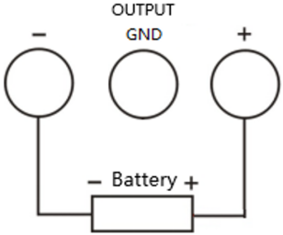
- Charging: Press the "ON/OFF" button (the backlight is green), and the power supply will charge the battery according to the charging curve.

3.7 Fuse test
The fuse blow mode measures the fuse's breaking characteristics, including "Fuse time" and "Fuse current". The " Fuse time " mode measures the Ampere-Second Characteristic (A-T) characteristics, while the " Fuse current " mode scans and measures the critical instantaneous breaking current value (instantaneous blow threshold) of the fuse.

3.7.1 Fuse time mode
Take the 5A fuse as an example.
- Connect the output lead: connect the power output terminal to the fuse in the way shown in the figure.
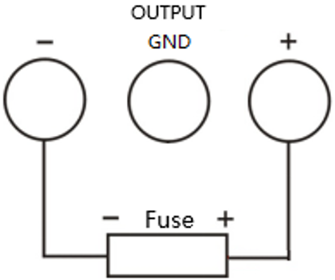
- Turn on the power: press the power switch to start the power and enter the working state.
- Enter the only fuse time mode: press the Mode button to switch to the fuse mode, short press the adjustment knob, then adjust the knob, and finally short press the adjustment knob, referring to the drop menu of function mode switch in 3.3.
- Current setting: Set the current to 8A through a digital key or adjustment knob.
- Open the output: press the "ON/OFF" button (the backlight is green), and the power supply will work in constant current source state.
- Check the fuse time: When the fuse blows, the fuse time stops. This time is the time required for the fuse to blow after passing the 8A current value.

3.7.2 Fuse current mode
Take the 5A fuse as an example.
- Connect the output lead: connect the power output terminal to the fuse in the way shown in the figure.
- Turn on the power: press the power switch to start the power and enter the working state.
- Enter fuse current mode: Press the Mode button to switch to fuse mode, short press the adjustment knob, then turn on the adjustment knob, and finally short press the adjustment knob to switch according to the drop menu of function mode switch in Section 3.3.
- Parameter setting: current start point, current end point, current step, delay detection.
- Open the output: press the "ON/OFF" button (the backlight is green), and the power supply will work in constant current source state.
- Check the fuse current: When the fuse blows, the output current stops increasing, and the current value is the instantaneous current value at which the fuse blows.
- Performance index
  - Display resolution
Voltage resolution | ＜100V: 10mV  ≥100V: 100mV
Current resolution | ＜100A: 10mA  ≥100A: 100mA
Power resolution | ＜10W: 1mW  ≥10W: 10mW  ≥100W: 0.1W  ≥1000W: 1W
Time resolution | Normal mode: 1 hour, 1 minute, 1 second  Charging mode: 1 hour, 1 minute, 1 second  Fuse mode: 1ms

  - Time display range
Normal mode time display range: 0~256h
Charging mode time display range: 0~100h
Fuse mode test time range: 0~9999s

  - Output parameters (when using this specification, ensure that the power on is more than 10s)
Voltage stability: ≤± (0.2%+5digits)
Current stability: ≤± (0.5%+5digits)
Load stability: ≤0.5%
Ripples and noise: ≤1% (effective value)
Fuses measurement time accuracy: 50ms

  - Voltage and current value preset accuracy
Output voltage preset accuracy: ±0.1V
Output steady current preset accuracy: ±0.1A

  - operational environment
Indoor use
Altitude: less than 2000m
Environment temperature: 5℃~40℃
Relative humidity: <80%

  - Storage environment
Indoor storage
Environment temperature: 0~70℃
Relative humidity: <70%

  - power input
AC220V±10%,50Hz (or AC110V±10%,60Hz manual switch)

  - appendix
Specification*1; certificate of conformity*1; power cord (for models below 2400W)*1

  - Bare machine size
<2400W model: 330 (D) × 250 (W) × 155 (H) mm
Models with ≥2400W:410 (D) × 250 (W) × 155 (H) mm

  - Packing size
<2400W model: 420 (D) × 310 (W) × 220 (H) mm
Models with ≥2400W:497 (D) × 310 (W) × 220 (H) mm

  - communicational parameter
Port rate: 9600
Start: 1
Data bits: 8
Check bit: None
Stop position: 1

  - Weight
type | ＜2400W | ≥2400W
net weight | About 5kg | About 7.5Kg

- Product toxic and harmful substances declaration
component  name | Products toxic and harmful substances or elements
component  name | lead  (Pb) | mercury  (Hg) | cadmium  (Cd) | hexavalent chromium  (Cr(VI)) | Polybrominated biphenyl  (PBB) | Polybrominated diphenyl ethers  (PBDE)
printed circuit assembly | X | O | O | O | O | O
transformer | X | O | O | O | O | O
connecting line | X | O | O | O | O | O
Hardware case | X | O | O | O | O | O
power line | X | O | O | O | O | O
Electronic aterial | O | O | O | O | O | O
Plastic panel | O | O | O | O | O | O
packing material | O | O | O | O | O | O
O: indicates that the content of the toxic and harmful substance in all homogeneous materials of the component is below the limit requirements specified in SJ/T11363-2006 standard.
X: indicates that the content of the toxic and harmful substance in at least one homogeneous material of the component exceeds the limit requirements specified in SJ/T11363-2006.
Note: This table shows that the product may contain these substances, but this information may be updated with technological development; "X" is marked because there is no alternative technology and components available at this stage, and it complies with the requirements of the Pollution Control Management Measures for Electronic Information Products of the People's Republic of China.
- conformally connected space
- We sincerely appreciate your choice of our power supply. Our company will strictly implement the national three-warranty policy. For non-human-induced quality issues of the product itself, you may process repairs, replacements, or returns with your invoice and warranty certificate. For items beyond the warranty period, only replacement parts fees will be charged.
- Please pack the products properly when delivering them. If there is any damage or loss during delivery, our company will not be responsible for it.
- Be sure to have the warranty card stamped and dated by the after-sales unit to ensure your rights.
- The following situations are not covered by the exemption service:
- Exceeding the validity period of three guarantees.
- Unauthorized alteration of the three package certificates.
- Damage caused by failure to use, maintain and keep the product as required in the product instructions.
- Damage to products caused by natural disasters, power grid failures or other force majeure factors.
- The accessories are not covered by the warranty.
- The product model or number on the three certificates does not match the physical goods.

warranty card
This card is the product warranty certificate, please be sure to keep it properly
Product Name (Product Model)
date of purchase
Vendors
customer name
Customer address
Customer phone
Fault description
Note: Free warranty service (excluding accessories) is available for 12 months. The shipping cost will be paid by the sender (only for mainland customers)

